Unit 4: Earth Systems and Resources
Name:
Topics:
- Plate Tectonics | VI. Watersheds
- Soil Formation and Erosion | VII. Solar Radiation and Earth’s Seasons
III. Soil Composition and Properties | VIII. Earth’s Geography and Climate
IV. Earth’s Atmosphere  V. Global Wind Patterns | IX. El Niño and La Niña

Vocabulary  - Climate  - Weather  - Troposphere  - Stratosphere  - Mesosphere  - Thermosphere  - Exosphere  - Albedo  - Tilt  - Saturation point  - Adiabatic heating/ cooling  - Latent heat release  - Atmospheric convection current  - Insolation | - Convection cells:  Hadley, Polar, Ferrell  - Coriolis effect  - Rain shadow  - Gyre  - Upwelling  - Thermohaline circulation  - ENSO  (El Niño/ Southern Oscillation, La Niña)  - Core/Mantle/Crust  - Asthenosphere  - Lithosphere  - Magma  - Hot spot  - Plate tectonics | - Subduction  - Plate boundaries  - Seafloor spreading  - Divergent/convergent  - Transform fault  - Seismic activity  - Earthquake  - Epicenter  - Richter scale  - Rock cycle  - Igneous/Sedimentary/ Metamorphic  - Physical/Chemical weathering  - Acid precipitation  - Rainshadow effect | - Erosion  - Parent material  - Soil degradation  - Horizons: O/A/E/B/C  - Water holding capacity/retention  - Porosity  - Permeability  - CEC (Cation exchange capacity)  - Soil texture triangle  - Saltwater intrusion  - Floodplain  - Watershed  - Watershed divide  - Intertropical convergence zone

- Geology & Plate Tectonics
Objective:
- Describe the geological changes and events that occur at convergent, divergent, and transform plate boundaries.

Computer Interactive and Videos
Computer Activity: http://www.learner.org/interactives/dynamicearth/index.html
A. Earth’s Structure
Layer of the Earth | Composition/Other notes
1. (Innermost)
2.
3.
4.

B. Plate Tectonics
Alfred Wegener suggested that the plates of the Earth today have not always been in the same place. The plate tectonics theory suggests that these plates have moved over time in relation to one another resulting in different interactions between landmasses.

The last supercontinent ___________________ began to break up __________________________ .

The modern theory of plate tectonics provides us with a framework for understanding what?

Complete game: “Continents Over Time”
C. Plates & Boundaries
How many tectonic plates make up the earth’s surface? _______
What are the 2 types of crust and how are they different?
1.

2.

Type of Boundary | Describe and give 1 real-life example | Draw a picture
1.
2.
3.

- Earthquakes (usually)  - Himalayas  - Island arcs  - Mid-Atlantic Ridge  - Mid-ocean ridge | - Mountain ranges  - Rift  - San Andreas Fault  - Seafloor spreading  - Subduction zone | - Slip-strike  - Tsunamis  - Volcanoes (usually)

D. Slip, Slide, & Collide
Write the following terms under the type of plate boundary it relates to. You will need to click through and read both screens.

Convergent | Divergent | Transform
Why do many volcanoes and earthquakes tend to be found on plate boundaries?

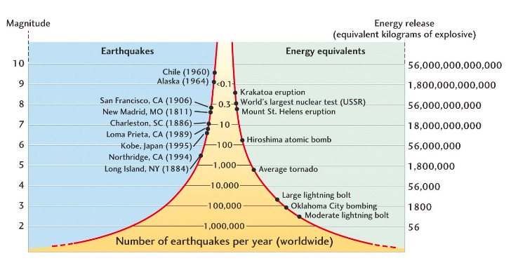
How many times greater in magnitude is an earthquake that measures 7.0 on the Richter scale as opposed to one that measures 3.0?

Focus: | Draw picture
Epicenter:

Earthquake Science! https://www.youtube.com/watch?v=Nt0m5JWa62w

Video: What is a Volcano? (3:13) https://www.youtube.com/watch?v=WgktM2luLok
Describe in your own words how volcanoes form and erupt.
What are two ways volcanoes have been necessary to form our current environment?

- 2.

Video: Mt. St. Helens Eruption (6:27) https://www.youtube.com/watch?v=-H_HZVY1tT4&t=1s
How can eruptions affect the environment and natural ecosystems? | How can eruptions affect humans?

Types of Rocks
 | Igneous | Sedimentary | Metamorphic
Formation
Types
Unique characteristics

- Soil Formation and Erosion
Objectives:
- Describe the characteristics and formation of soil.
- Identify and describe the soil horizons based on their composition and organic material.
- Describe soil erosion, desertification and the ecosystem services provided by soil.

Topic notes:
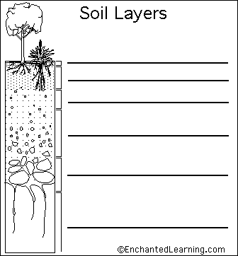

Important biome differences:
- Forests
- Grassland
- Rainforest
- Desert

ReadingWorld on the Edge: Chapter 3—Eroding Soils and Expanding Deserts http://www.earth-policy.org/images/uploads/book_files/wotebook.pdf
Why does Lester Brown call topsoil the “foundation of civilization”?

Why is soil erosion the “silent global crisis”?

Briefly explain how desertification occurs and dust bowls are formed (see p. 37).

List three regions or countries affected by soil degradation and desertification and give 2 pieces of data that support the claim.
1.

2.

3.

- Soil Composition and Properties
Topic notes:
Objectives:
- Describe similarities and differences among properties of different soil types.
- Describe the formation of soil and causes of soil degradation.

Using your soil texture chart, determine the following soil textures using the percentages given.
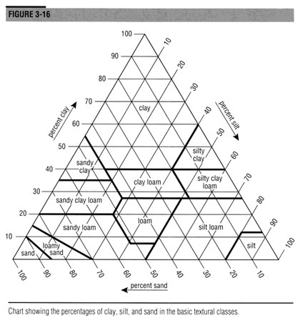
Soil Textural Triangle Practice Exercises
% Sand | % Silt | % Clay | Texture Name
75 | 10 | 15 | Sandy loam
10 | 83 | 7
20 | 20 | 70
42 |  | 37
 | 52 | 21
 | 35 | 50
64 | 30
50 |  | 40
36 |  |  | Clay loam
 |  |  | Silty clay
 |  |  | Loamy sand
 |  |  | Silt loam

- Earth’s Atmosphere
- Describe the four systems that provide the life support for our planet.
- Describe the structure and composition of the Earth’s atmosphere.
Topic notes:

V. Global Wind Patterns (Module 10)
- Explain how environmental factors can result in atmospheric circulation.
- Explain the Coriolis effect and its cause.

Topic notes:
Video: “Global Atmospheric Circulation” (2:24) https://www.youtube.com/watch?v=Ye45DGkqUkE

Video: “Coriolis Effect” (2:55) http://video.pbs.org/video/2365036901/
What is the Coriolis Effect? | Draw it!

- Watersheds
- Describe the characteristics of a watershed, including area, length, slope, soil, vegetation types, and boundaries with adjoining watersheds.
- Explain the importance of protecting watersheds at their source and solutions to downstream issues.
What is a watershed? Video
https://youtu.be/QOrVotzBNto (1:17)
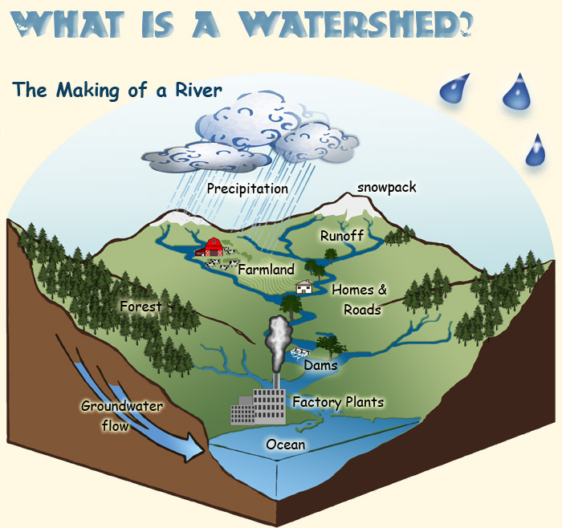

http://www.discoverwater.org/explore-watersheds/

What effects can dams have on watersheds?

What makes floodplains popular areas for human settlement?

What factors need to be considered when building housing on a waterway?

Video: Water: The Source of Life (8:42) https://ed.ted.com/featured/FJ4ywGH8#watch
Track the water from the source to the sink.
Location 1  Source: | The frejelón plant is an __________________ species, found nowhere else on earth. (look up this ecological term—not in video)
 | What service does the frejelón provide in the Andes?
 | What service does the moss provide?
Location 2  Midway along the journey: | What is added to the water as it runs through agricultural areas?
Location 3  Final destination: | Who relies on clean water in a city?
What is a water fund, and which nonprofit is working on it in Bogotá?

Why should the city of Bogotá pay for conservation efforts in the Páramos?

What has the Avellanada family agreed to do, and why?

What do you think about “water funds”? Would they work in the US? Why or why not?

- Solar Radiation and Earth’s Seasons
- Describe Earth’s movements including rotation, revolution & axial tilt.
- Explain the differential heating between equatorial & polar areas as a function of sunlight intensity and surface area covered.
- Explain Earth’s seasons in terms of its movements.

Topic notes:
Factors that affect the amount of solar energy at the surface of the earth (directly correlated with plant productivity)

What causes seasons?
- ____________________ (period of greatest solar radiation) occurs in the Northern Hemisphere when it is ______________________________________________________
- Sun rises _______________ and stays above the horizon _______________, rays strike ground ______________________________ (less of an angle) –the opposite of this is when ______________ occurs
- Earth is actually closest to sun in ________________ (Jan. perihelion) not summer (July aphelion)
Seasons are NOT caused by _______________________________________________________ !
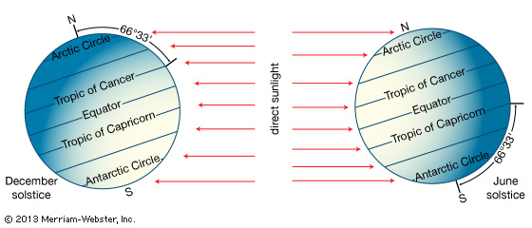

Video: Bill Nye Explains Seasons https://www.youtube.com/watch?v=KUU7IyfR34o
- Seasons are caused by
- Temperatures being colder at the poles, warmer at the equator caused by

- Earth’s Geography and Climate (Module 10)
- Explain how weather and climate are also affected by geologic and geographic factors, such as mountains and ocean temperature.
- Describe a rain shadow and how it forms.

Climate patterns determined by:
1.

2.

3.

Draw and label a rain shadow effect.

- El Niño and La Niña (Module 11)
- Describe the formation, effects and environmental changes that result from El Niño and La Niña events (El Niño-Southern Oscillation, or ENSO).

___________________ : Large-scale water circulation that moves clockwise in the Northern Hemisphere and counter-clockwise in the Southern.
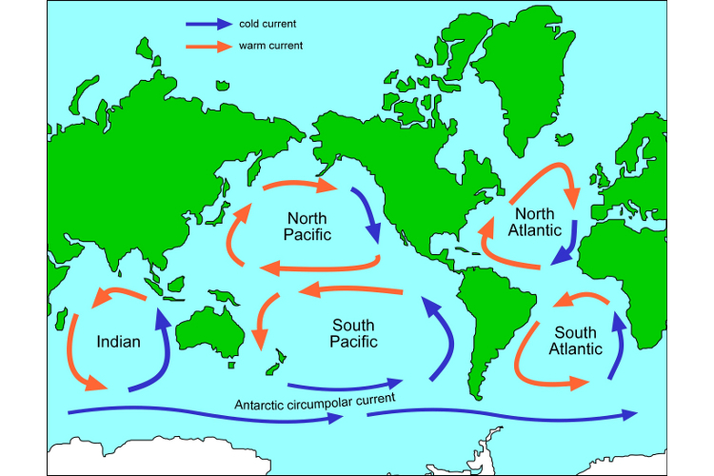

___________________________: upward movement of ocean water causes mixing, bringing cool and nutrient-rich water from the bottom of the ocean to the surface
The warm water supports large populations of phytoplankton, zooplankton, fish, fish-eating seabirds
Upwellings occur when:
1. Far from shore:

2. Along steep western coasts of continents:
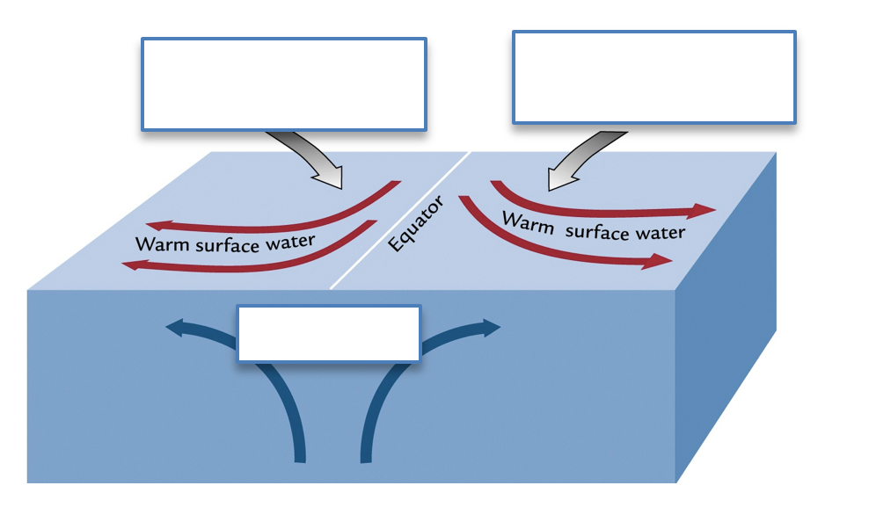
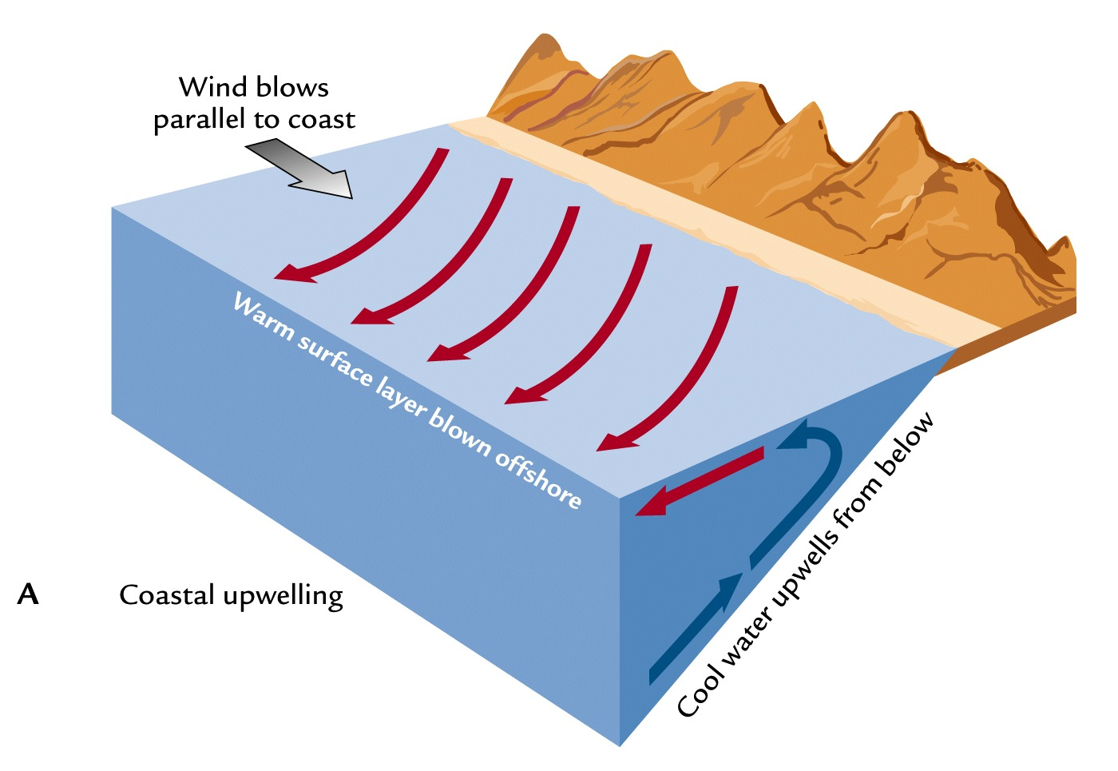
What happens in an El Niño?

Possible Effects of El Niño:

La Niña:

